WEEK FOUR CHALLENGE 1
/**Challenge 1: Find the Smallest Number
Understand:
Input: An array of numbers [12, 5, 8, 20, 3].
Output: The single smallest value in that set.
Edge Case: If the array is empty, numbers[0] would be undefined.
Plan:
Initialize a variable smallest and set it to the first item in the array.
Loop through every number in the array.
If the current number is less than smallest, update smallest to be that number.
Print the final result.
Execute:**/

let numbers = [12, 5, 8, 20, 3];
let smallest = numbers[0];
for (let i = 0; i < numbers.length; i++) {
if (numbers[i] < smallest) {
smallest = numbers[i];
}
}
console.log("Smallest: " + smallest);

Reflect: Starting at numbers[0] ensures we compare against a value actually present in the data.
Screenshot with terminal
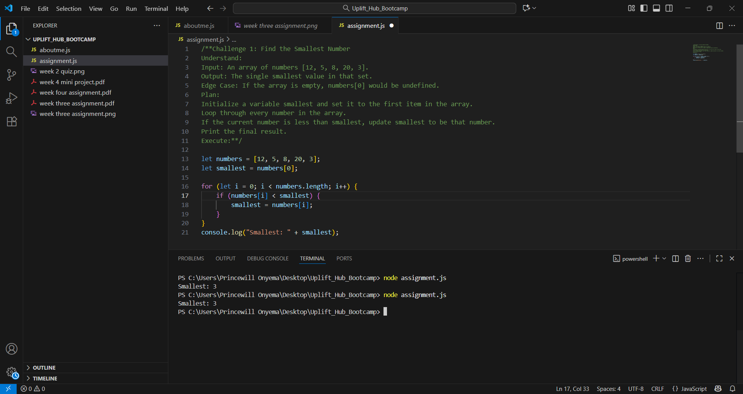

WEEK FOUR CHALLENGE 2
let numbers = [12, -5, 8, 20, 3];
let text = "bootcamp";
let tempCelsius = 30;
for (let i = 0; i < numbers.length; i++) {
}
/*Challenge 2: Calculate the Average
Understand:
Input: Array of numbers.
Output: The average (total sum divided by the number of elements).
Edge Case: An empty array would cause a "division by zero" error, resulting in NaN.
Plan:
Create a total variable starting at 0.
Loop through the array and add each number to the total.
Divide the total by the numbers.length.
Print the average.
Execute:**/
let total = 0;
for (let i = 0; i < numbers.length; i++) {
total = total + numbers[i];
}
let average = total / numbers.length;
console.log("Average: " + average);

Reflect: This uses the "accumulator pattern" where the total grows with each loop cycle.
Screenshot with terminal
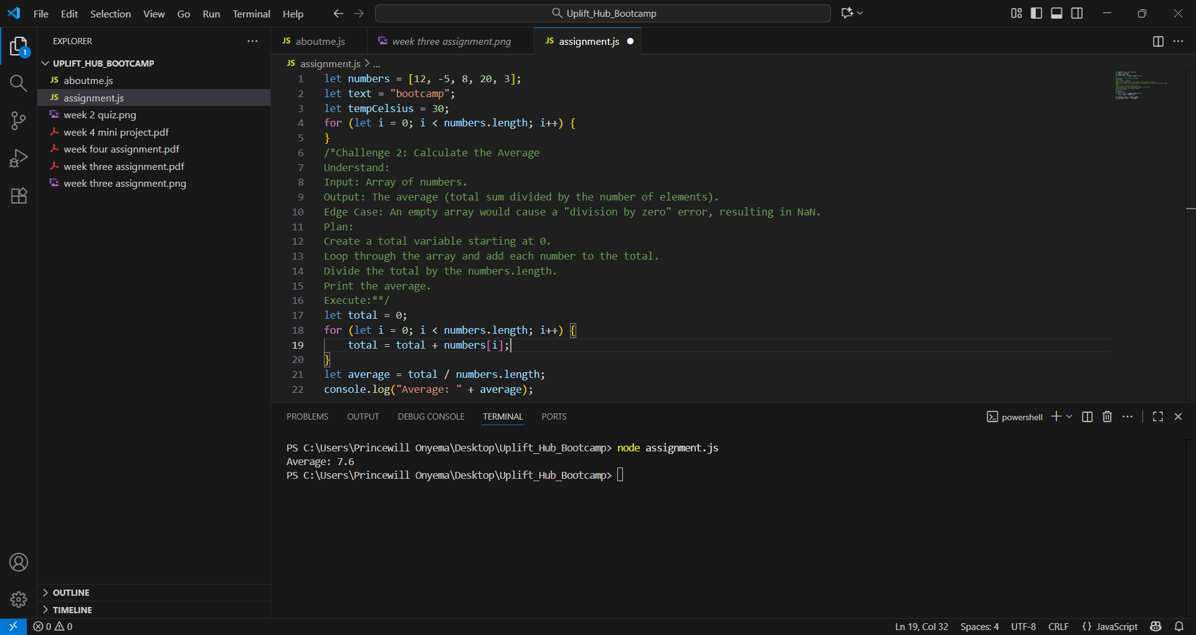

WEEK FOUR CHALLENGE 3
let numbers = [12, -5, 8, 20, 3];
let text = "bootcamp";
let tempCelsius = 30;
for (let i = 0; i < numbers.length; i++) {
}
/**Challenge 3: Search for a Number
Understand:
Input: The numbers array and a target number (8).
Output: A boolean (true or false).
Plan:
Set target to 8 and found to false.
Loop through the array.
If any element matches the target, change found to true and stop the loop immediately.
Print the found status.
Execute:**/
/**Reflect: The break keyword is vital for efficiency; once we find the number, there's no need to check the rest of the list.**/
let target = 8;
let found = false;

for (let i = 0; i < numbers.length; i++) {
if (numbers[i] === target) {
found = true;
break; // Stops the loop for better performance
}
}
console.log("Found: " + found);
SCREENSHOT WITH TERMINAL
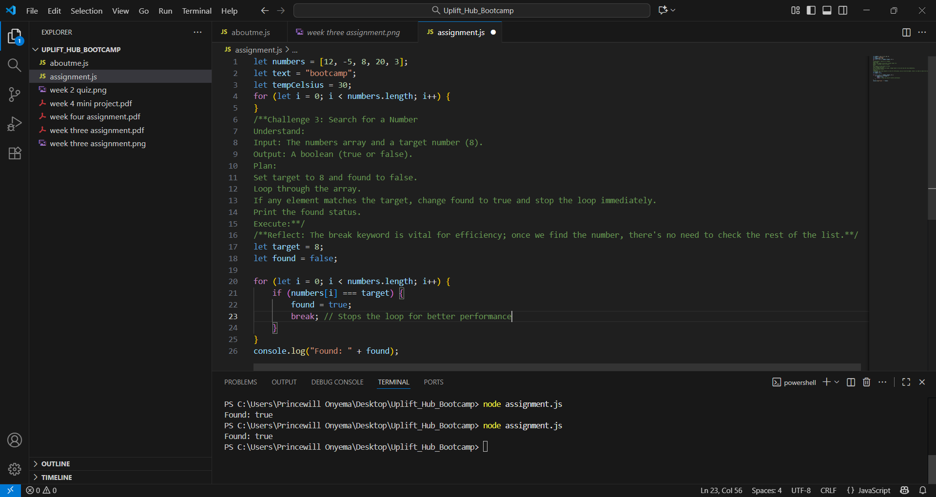

WEEK FOUR CHALLENGE 4
/**Challenge 4: Remove Vowels
Understand:
Input: The string "bootcamp".
Output: The string without a, e, i, o, or u ("btcmp").
Plan:
Create an empty string called result.
Loop through the text string.
Check if the current letter (converted to lowercase) is not a vowel.
If it's not a vowel, add it to the result.
Execute:**/
let text = "bootcamp";
let result = "";

for (let i = 0; i < text.length; i++) {
let letter = text[i].toLowerCase();
if (letter !== 'a' && letter !== 'e' && letter !== 'i' && letter !== 'o' && letter !== 'u') {
result = result + text[i];
}
}
console.log("Without vowels: " + result);
//Reflect: We use && (AND) because a letter must fail to be every single vowel to be kept./
Screenshot with terminal
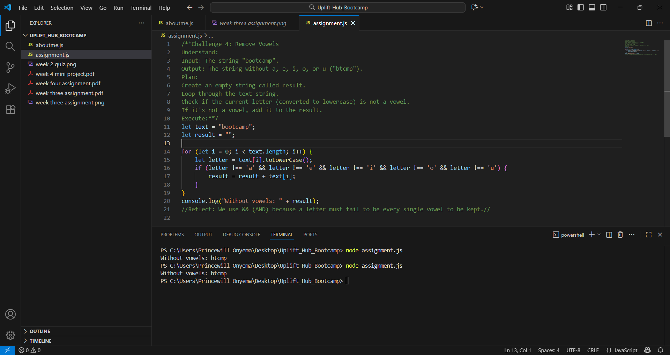

WEEK FOUR CHALLENGE 5
let numbers = [12, -5, 8, 20, 3];
let text = "bootcamp";
/**let tempCelsius = 30;

for (let i = 0; i < numbers.length; i++) {
}
/**Challenge 5: Temperature Converter
Understand:
Input: Celsius value (30).
Output: Fahrenheit value (86).
Plan: Apply the formula: $(Celsius \times \frac{9}{5}) + 32$.Store the result in a variable and print it.
Execute:**/
/**Reflect: This is a sequential algorithm—it runs from top to bottom with no loops or "if" branches.**/
let tempCelsius = 30;
let fahrenheit = (tempCelsius * (9/5)) + 32;
console.log(tempCelsius + "C = " + fahrenheit + "F");
Screenshot with terminal
